
SHOCKING: How the UGX 5.51 Billion Centenary Bank Fraud Scandals were stealthily quashed by High-Ranking influence.
Centenary Bank, Uganda's largest, and revered indigenous Catholic Commercial Bank is at the centre of massive fraud scandals involving two huge heists totalling UGX 5.51 Billion (approximately USD 1.5 million). The shocking revelations expose a web of deceit, theft, Corruption, and incompetence that left the Bank’s integrity and security in tatters.
In our previous extensive Publications, it was confirmed that in October 2023 and August 2024, the Bank suffered two major heists, with the culprits siphoning UGX 3.56 Billion and UGX 1.95 Billion, respectively.
This publication learned that, instead of taking swift and decisive action to recover the stolen funds, the Bank’s top Management, led by the Managing Director Mr. Fabian Kasi who has served the Bank for more than a decade and the Executive Director Mr. Balikudembe Joseph, allegedly orchestrated a cover-up.
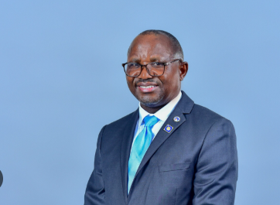
Mr. Fabian Kasi – Managing Director.
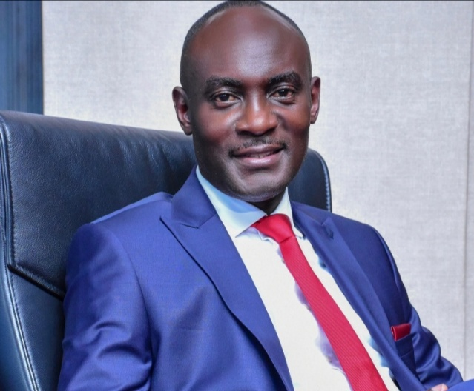
Mr. Balikuddembe Joseph – Executive Director
Investigations revealed that the frauds were internally orchestrated, involving a syndicate of Bank Officials, security Personnel, and external mobile money Agents of MTN Uganda and the Bank’s Partners handling Agent Banking respectively. The Bank’s top Brass was accused of influencing Insurers to refund the lost funds without any aggressive effort of recovery of the stolen funds, while innocent lower-ranking IT officers were implicated in fictitious internal and external investigations and subsequently dismissed without substantial evidence of commission of the frauds.
The Bank’s response to the frauds was woefully inadequate. Instead of conducting a thorough investigation, the Bank hired a Digital Forensics Company-QA Consults Ltd with ties to the top Management, which produced a flawed report that exonerated the perpetrators. The critical Core Banking System was not forensically analysed, and the Tellers whose credentials were used in the frauds were shockingly retained and even promoted like a one Nicola Nakimuli with ties to the 3.56 Billion fraud of October 2023.
The sample transactions of the October 2023 frauds were seen by the eastafricanwatch.net as shown below.
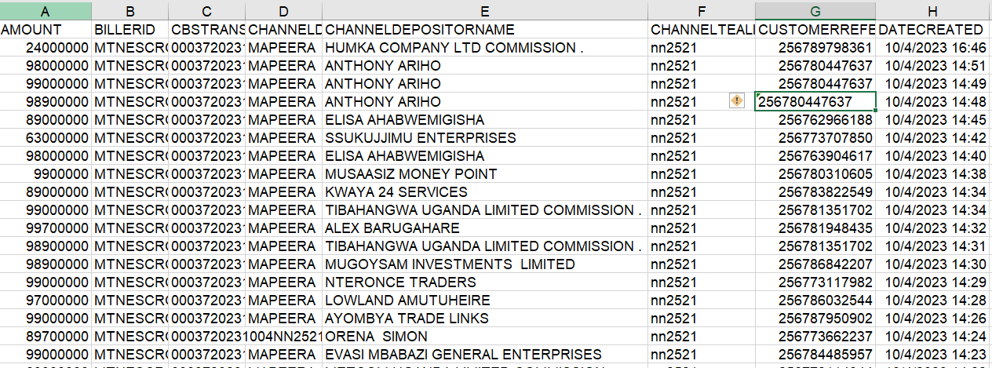
The Bank’s Audit and Compliance departments were highly compromised, with erroneous reports submitted to the Regulator, Bank of Uganda, and the Bank’s Board of Directors. The investigations, which were supposed to be independent, were largely influenced by the top officials, yielding no positive results with stagnated Criminal cases at Central Police Station (CPS) Kampala and no prosecution of the recipients of the stolen Funds.
These scandals raise serious concerns about the Bank’s governance, risk management, and internal controls. The fact that the top Management was able to manipulate the investigations and cover up the frauds suggests a deep-seated rot within the institution.
This publication further learned a shocking revelation how the top Bank officials connived with the external Auditors and some staff of Bank of Uganda, the Financial Intelligence Authority, and Security Agencies which impeded independent investigations into these scandals. The perpetrators were, not brought to book, and the Bank’s Management was not held accountable for their failure to protect the Bank’s Assets and Customer Savings. This underscores the urgent need for overhauling the existing top Management in order to save the Bank from the defunct Crane Bank debacle.

